1、Operating Environment
1.1、System：
- Ubuntu22.04
1.2、Ros2 Version：
- humble

2、CAN Card Connection Methods
2.1、Connecting the CAN Card to the Chassis:：
- Connect the chassis to the CAN card as below diagram. CAN-H of the chassis to the CANH of the CAN card; and CAN-L of the chassis to the CANL of the CAN card.

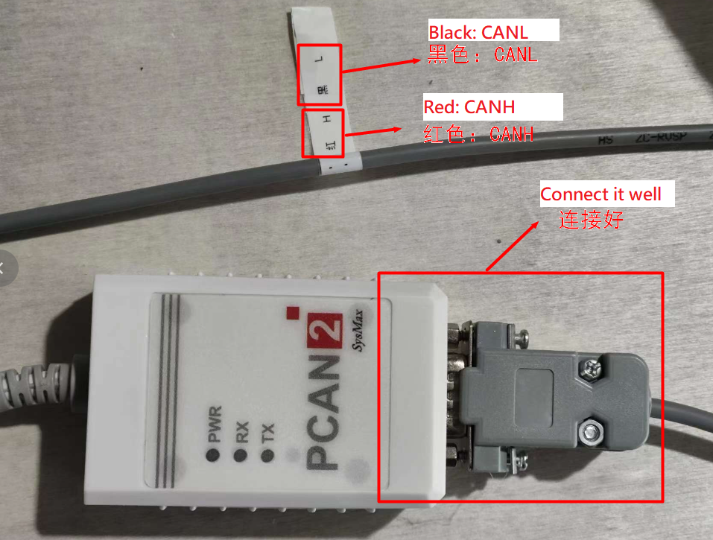

2.2、Connecting the CAN Card to the Computer:
- Plug one end of the USB cable directly into the computer's USB port.

3、CAN Card Configuration:

3.1、Status after connecting the CAN Card to the Computer:
- The PWR light will be on

3.2、Verify Connections:
- Open a terminal and type lsusb. You should see PEAK System PCAN-USB, as below diagram:

3.3、Enable the CAN interface:
- Enter the following command:
sudo ip link set can0 up type can bitrate 500000
  - If the chassis is powered on, the blue RX light will flash, and the red TX light will also illuminate. The RX light flashing indicates CAN card is receiving data. TX light flashing indicates sending data.

4、Data Viewing:
4.1、Install the Required Tools:
- Use the following command:
4.2、View Data:
- Use the following command:
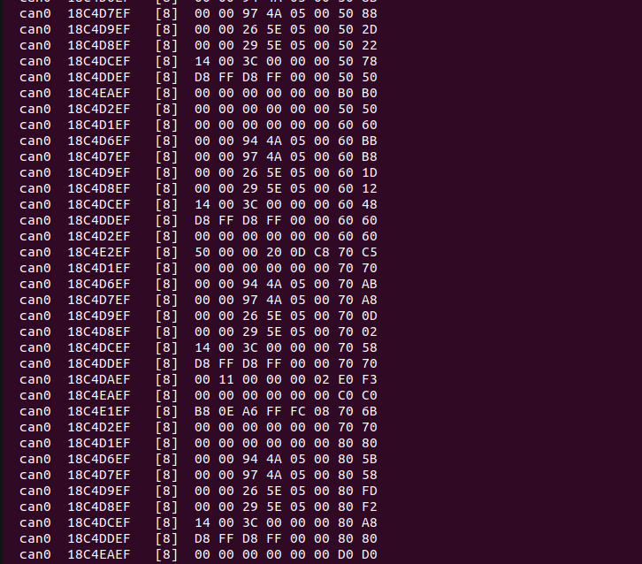

5、Running the Program
5.1、File Storage:
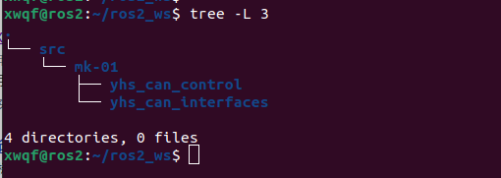

5.2、Compile the Code:
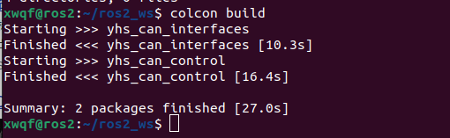
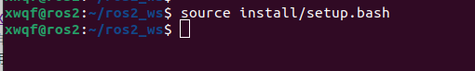
5.3、Set Environment Variables:

5.4、Launch the Program
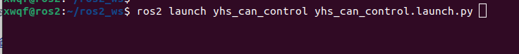
If no further output is displayed after the initial print statement as below, it indicates normal data reception.
6、Data Transmission数据发送
6.1、In order to use rqt_publisher tool, ensure the remote control is set to command mode. It is recommended to elevate the chassis.

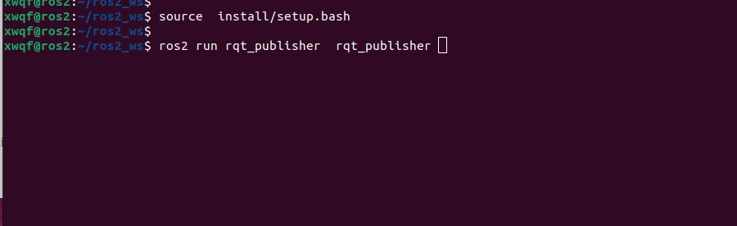

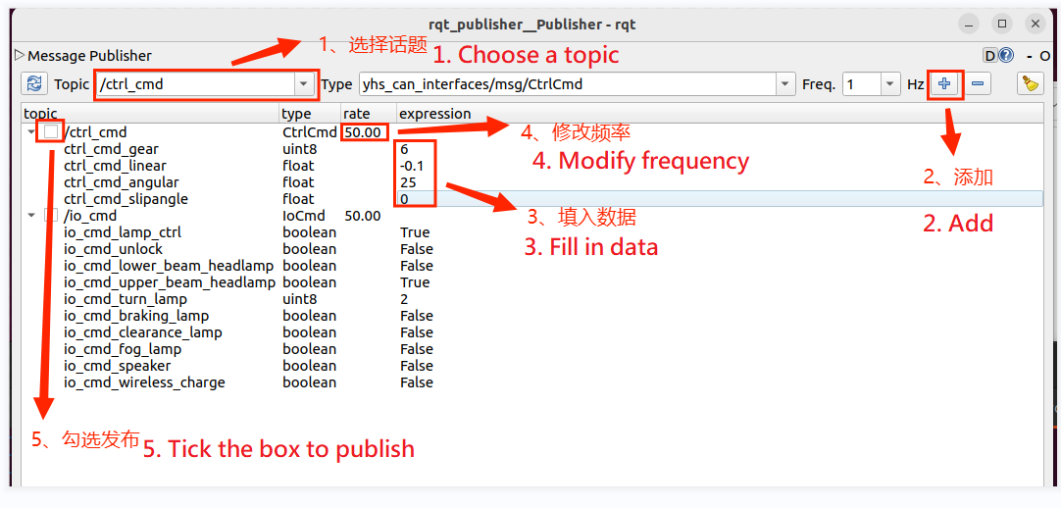

- Topic Descriptions
7.1、Speed Control: Publish frequency has to be above 30hz
速度控制，发布频率要在30hz以上
Message Type | yhs_can_interfaces/msg/CtrlCmd
Topic Name | ctrl_cmd
Variable | Type | Description
ctrl_cmd_gear | uint8 | Target gear position  00：Disable  01：Parking  02：Neutral  06：4T4D-Gear  08：Lateral movement-Gear
ctrl_cmd_x_linear | float32 | Target linear velocity on X-axis  Unit: m/s
ctrl_cmd_z_angular | float32 | Target angular velocity on Z-axis  Unit: °/s
ctrl_cmd_y_linear | float32 | Target linear velocity on Y-axis  Unit: m/s

7.2、Steering Control: Publish frequency has to be above 30hz
Message Type | yhs_can_interfaces/msg/SteeringCtrlCmd
Topic Name | steering_ctrl_cmd
Variable | Type | Description
ctrl_cmd_gear | uint8 | Target gear position  00：Disable  01：Parking  02：Neutral  05：4T4D-Gear  07：Lateral movement-Gear
steering_ctrl_cmd_velocity | float32 | Target steering wheel velocity  Unit: m/s
steering_ctrl_cmd_steering | float32 | Target steering wheel angle  Unit: °

7.3、IO Control: Some features are reserved and may not be available on the chassis.
Message Type | yhs_can_interfaces/msg/IoCmd
Topic Name | io_cmd
Variable | Type | Description
io_cmd_lamp_ctrl | bool | Lamp control mode  0 = Automatic control based on state  1 = Manual control
io_cmd_unlock | bool | Safety parking unlock switch  0 = Invalid  1 = Unlock enabled
io_cmd_lower_beam_headlamp | bool | Low beam headlight switch  0 = Off  1 = On
io_cmd_upper_beam_headlamp | bool | High beam headlight switch  0 = Off  1 = On
io_cmd_turn_lamp | uint8 | Turn signal switch  0 = Off  1 = Left turn signal on  2 = Right turn signal on
io_cmd_braking_lamp | bool | Brake light switch  0 = Off  1 = On
io_cmd_clearance_lamp | bool | Clearance light switch  0 = Off  1 = On
io_cmd_fog_lamp | bool | Fog light switch  0 = Off  1 = On
io_cmd_speaker | bool | Speaker Switch  0 = Off  1 = On
io_cmd_wireless_charge | bool

7.4，Chassis data subscription: some items are reserved and the chassis may not provide feedback for these data points.
Message Type | yhs_can_interfaces/msg/ChassisInfoFb
Topic Name | chassis_info_fb
Variable | Type | Description
ctrl_fb.ctrl_fb_gear | uint8 | Current gear feedback  00：Disable  01：Parking  02：Neutral  06：4T4D-Gear  08：Lateral movement-Gear
ctrl_fb.ctrl_fb_x_linear | float32 | Current X-axis linear velocity feedback  Unit: m/s
ctrl_fb.ctrl_fb_z_angular | float32 | Current Z-axis angular velocity feedback  Unit: °/s
ctrl_fb.ctrl_fb_y_linear | float32 | Current Y-axis linear velocity feedback  Unit: m/s
steering_ctrl_fb.steering_ctrl_fb_gear | uint8 | 00：Disable  01：Parking  02：Neutral  05：4T4D-Gear  07：Lateral movement-Gear
steering_ctrl_fb.steering_ctrl_fb_velocity | float32 | Current steering wheel velocity feedback  Unit: m/s
steering_ctrl_fb.steering_ctrl_fb_steering | float32 | Current steering wheel angle feedback  Unit: °
io_fb.io_fb_lamp_ctrl | bool | Lamp control mode feedback  0 = Automatic control based on state  1 = Manual control自由控制
io_fb.io_fb_unlock | bool | Safety parking unlock feedback  0 = Invalid  1 = Unlock successfully
io_fb.io_fb_lower_beam_headlamp | bool | Low beam headlight status feedback  0 = Off  1 = On
io_fb.io_fb_upper_beam_headlamp | bool | High beam headlight status feedback  0 = Off  1 = On
io_fb.io_fb_turn_lamp | uint8 | Turn signal status feedback  0 = Off  1 = Left turn signal on  2 = Right turn signal on
io_fb.io_fb_braking_lamp | bool | Brake light status feedback  0 = Off  1 = On
io_fb.io_fb_clearance_lamp | bool | Clearance light status feedback  0 = Off  1 = On
io_fb.io_fb_fog_lamp | bool | Fog light status feedback  0 = Off  1 = On
io_fb.io_fb_speaker | bool | Speaker Status feedback  0 = Off  1 = On
io_fb.io_fb_fl_impact_sensor | bool | Front-left impact sensor feedback  0 = Off  1 = On
io_fb.io_fb_fm_impact_sensor | bool | Front-middle impact sensor feedback  0 = Off  1 = On
io_fb.io_fb_fr_impact_sensor | bool | Front-right impact sensor feedback  0 = Off  1 = On
io_fb.io_fb_rl_impact_sensor | bool | Rear-left impact sensor feedback  0 = Off  1 = On
io_fb.io_fb_rm_impact_sensor | bool | Rear-middle impact sensor feedback  0 = Off  1 = On
io_fb.io_fb_rr_impact_sensor | bool | Rear-right impact sensor feedback  0 = Off  1 = On
io_fb.io_fb_fl_drop_sensor | bool | Front-left drop sensor feedback  0 = Off  1 = On
io_fb.io_fb_fm_drop_sensor | bool | Front-middle drop sensor feedback  0 = Off  1 = On
io_fb.io_fb_fr_drop_sensor | bool | Front-right drop sensor feedback  0 = Off  1 = On
io_fb.io_fb_rl_drop_sensor | bool | Rear-left drop sensor feedback  0 = Off  1 = On
io_fb.io_fb_rm_drop_sensor | bool | Rear-middle drop sensor feedback  0 = Off  1 = On
io_fb.io_fb_rr_drop_sensor | bool | Rear-right drop sensor feedback  0 = Off  1 = On
io_fb.io_fb_estop | bool | Emergency stop status feedback  0 = Off  1 = On
io_fb.io_fb_joypad_ctrl | bool | Remote control status feedback  0 = Off  1 = On
io_fb.io_fb_charge_state | bool | Charging pile status feedback  0 = Off  1 = On
lr_wheel_fb.lr_wheel_fb_velocity | float32 | Current left wheel velocity feedback  Unit: m/s
lr_wheel_fb.lr_wheel_fb_pulse | int32 | Current left wheel pulse count feedback  Pulses per rotation:  N = encoder resolution × reduction ratio
rr_wheel_fb.r_wheel_fb_velocity | float32 | Current right wheel velocity feedback  Unit: m/s
rr_wheel_fb.r_wheel_fb_pulse | int32 | Current right wheel pulse count feedback  Pulses per rotation:  N = encoder resolution × reduction ratio
lf_wheel_fb.lf_wheel_fb_velocity | float32 | Current left-front wheel velocity feedback  Unit: m/s
lf_wheel_fb.lf_wheel_fb_pulse | int32 | Current left-front wheel pulse count feedback  200,000 pulses per rotation (Encoder: 2500 resolution, 4x, 20 reduction ratio)  Unit: 1
rf_wheel_fb.rf_wheel_fb_velocity | float32 | Current right-front wheel velocity feedback  Unit: m/s
rf_wheel_fb.rf_wheel_fb_pulse | int32 | Current right-front wheel pulse count feedback  200,000 pulses per rotation (Encoder: 2500 resolution, 4x, 20 reduction ratio)  Unit: 1
front_angle_fb.front_angle_fb_l | float32 | Left-front servo joint angle feedback  Unit: °
front_angle_fb.front_angle_fb_r | float32 | Right-front servo joint angle feedback  Unit: °
rear_angle_fb. rear_angle_fb_l | float32 | Left-rear servo joint angle feedback  Unit: °
rear_angle_fb.rear_angle_fb_r | float32 | Right-rear servo joint angle feedback  Unit: °
bms_flag_fb.bms_flag_fb_soc | uint8 | Current battery percentage
bms_flag_fb.bms_flag_fb_single_ov | bool | Single cell overvoltage protection  0 = Off  1 = On
bms_flag_fb.bms_flag_fb_single_uv | bool | Single cell undervoltage protection  0 = Off  1 = On
bms_flag_fb.bms_flag_fb_ov | bool | Group overvoltage protection  0 = Off  1 = On
bms_flag_fb.bms_flag_fb_uv | bool | Group undervoltage protection  0 = Off  1 = On
bms_flag_fb.bms_flag_fb_charge_ot | bool | Over-temperature charging protection  0 = Off  1 = On
bms_flag_fb.bms_flag_fb_charge_ut | bool | Under-temperature charging protection充电低温保护  0 = Off  1 = On
bms_flag_fb.bms_flag_fb_discharge_ot | bool | Over-temperature discharge protection放电过温保护  0 = Off  1 = On
bms_flag_fb.bms_flag_fb_discharge_ut | bool | Under-temperature discharge protection放电低温保护  0 = Off  1 = On
bms_flag_fb.bms_flag_fb_charge_oc | bool | Overcurrent charging protection  0 = Off  1 = On
bms_flag_fb.bms_flag_fb_discharge_oc | bool | Overcurrent discharge protection  0 = Off  1 = On
bms_flag_fb.bms_flag_fb_short | bool | Short circuit protection  0 = Off  1 = On
bms_flag_fb.bms_flag_fb_ic_error | bool | Front-end detection IC error  0 = Off  1 = On
bms_flag_fb.bms_flag_fb_lock_mos | bool | Software lock MOS  0 = Off  1 = On
bms_flag_fb.bms_flag_fb_charge_flag | bool | Charging status flag  0 = Off  1 = On
bms_flag_fb.bms_flag_fb_hight_temperature | float32 | Current maximum battery temperature  Unit: ℃
bms_flag_fb.bms_flag_fb_low_temperature | float32 | Current minimum battery temperature  Unit: ℃
bms_fb.bms_fb_voltage | float32 | Current battery voltage  Unit: V
bms_fb.bms_fb_current | float32 | Current battery current  Unit: A
bms_fb.bms_fb_remaining_capacity | float32 | Current remaining battery  Unit: Ah

